**CH11 Managing Knowledge**

學習目標:

* 1. 知識管理系統在企業中的作用是什麼？
  2. 什麼類型的系統用於企業範圍的知識管理，以及它們如何為企業提供價值？
  3. 知識工作系統(knowledge work systems)的主要類型是什麼，它們如何為企業創造價值？
  4. 使用智慧科技進行知識管理有哪些商業好處？
* Why is it important that global performance management be delivered using Web-based technologies rather than traditional software running on corporate servers and PCs? What people and organizational difficulties do you think firms will face when implementing these global systems? Do firms become too dependent on database firms like Oracle?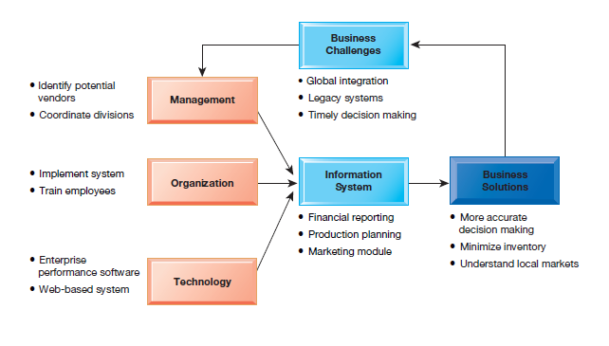

1. What is the role of knowledge management systems in business?
   * Preface

* Knowledge management and collaboration systems are among the fastest growing areas of corporate and government software investment.
* Knowledge management and collaboration are closely related.
* Knowledge that cannot be communicated and shared with others is nearly useless.
* Information economy
* 37 percent U.S. labor force: knowledge and information workers
* 45 percent U.S. GDP from knowledge and information sectors
* Substantial part of a firm’s stock market value is related to intangible assets: knowledge, brands, reputations, and unique business processes
* Well-executed knowledge-based projects can produce extraordinary ROI
  + Important Dimensions of Knowledge
* Preface
* There is an important distinction between data, information, knowledge, and wisdom.
* wisdom is thought to be the collective and individual experience of applying knowledge to the solution of problems.
* Wisdom involves where, when, and how to apply knowledge.
* Knowledge is both an individual attribute and a collective attribute of the firm.
* Knowledge is a cognitive, even a physiological, event that takes place inside people’s heads
* Knowledge residing in the minds of employees that has not been documented is called tacit knowledge
* knowledge that has been documented is called explicit knowledge
* Knowledge can reside in e-mail, voice mail, graphics, and unstructured documents as well as structured documents.
* Knowledge is “sticky” and not universally applicable or easily moved
* knowledge is thought to be situational and contextual.
* Organizational Learning and Knowledge Management
* knowledge-based core competencies of firms
  + - key organizational assets
    - Knowing how to do things effectively and efficiently in ways that other organizations cannot duplicate is a primary source of profit
    - competitive advantage that cannot be purchased easily by competitors in the marketplace
* organizations create and gather knowledge using a variety of organizational learning mechanisms.
* organizational learning
  + - organizations that learn adjust their behavior to reflect that learning by creating new business processes and by changing patterns of management decision making.
  + The Knowledge Management Value Chain
* Preface
* Knowledge management
  + - the set of business processes developed in an organization to create, store, transfer, and apply knowledge.
    - increases the ability of the organization to learn from its environment and to incorporate knowledge into its business processes.

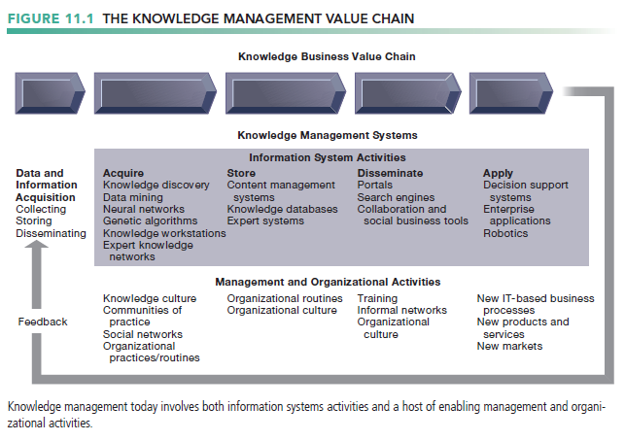

* Knowledge Acquisition
* Documenting tacit and explicit knowledge
  + - Storing documents, reports, presentations, best practices
    - Unstructured documents (e.g., e-mails)
    - Developing online expert networks
* developing online expert networks
* create new knowledge by discovering patterns in corporate data or by using knowledge workstations where engineers can discover new knowledge.
* Tracking data from TPS and external sources
* Knowledge Storage
* Databases
* Document management systems
* Role of management
  + - Support development of planned knowledge storage systems.
    - Encourage development of corporate-wide schemas for indexing documents.
    - Reward employees for taking time to update and store documents properly.
* Knowledge Dissemination
* Portals, wikis
* E-mail, instant messaging
* Search engines
* Collaboration tools
* How can managers and employees discover, in a sea of information and knowledge, that which is really important for their decisions and their work
  + - Training programs, informal networks, and shared management experience help managers focus attention on important information.
* Knowledge Application
* To provide return on investment, organizational knowledge must become systematic part of management decision making and become situated in decision-support systems
* new knowledge must be built into a firm’s business processes and key application systems
  + - enterprise applications for managing key internal business processes
    - relationships with customers and suppliers
* Management supports this process by creating based on new knowledge
  + - new business practices, new products and services, and new markets for the firm.
* Building Organizational and Management Capital: Collaboration, Communities of Practice, and Office Environments
* Communities of practice (COPs)
  + - informal social networks of professionals and employees within and outside the firm who have similar work-related activities and interests.
    - self-education and group education, conferences, online newsletters, and day-to-day sharing of experiences and techniques to solve specific work problems
* COPs can make it easier for people to reuse knowledge by pointing community members to useful documents, creating document repositories, and filtering information for newcomers.
* COPs members act as facilitators, encouraging contributions and discussion.
* COPs can also reduce the learning curve for new employees
* COPs can act as a spawning ground for new ideas, techniques, and decision-making behavior.
  + Types of Knowledge Management Systems
* Enterprise-wide knowledge management systems
* general-purpose firmwide efforts to collect, store, distribute, and apply digital content and knowledge.
  + - searching for information, storing both structured and unstructured data, and locating employee expertise within the firm.
* Knowledge work systems (KWS)
* built for engineers, scientists, and other knowledge workers charged with discovering and creating new knowledge for a company.
* Intelligent techniques
* Knowledge management also includes a diverse group of intelligent techniques , such as data mining, expert systems, neural networks, fuzzy logic, genetic algorithms, and intelligent agents.

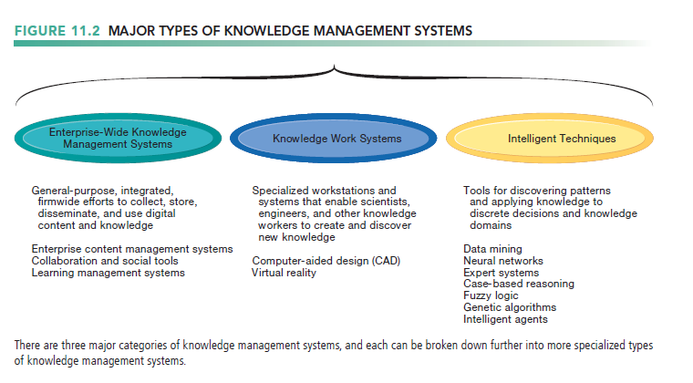

1. What types of systems are used for enterprise-wide knowledge management, and how do they provide value for businesses?
   * Enterprise Content Management Systems

* Structured knowledge
* explicit knowledge that exists in formal documents as well as in formal rules that organizations derive by observing experts and their decision-making behaviors.
* Reports, presentations
* Formal rules
* Semistructured documents
* E-mails, videos
* Unstructured, tacit knowledge
* 80 percent of an organization’s business content is semistructured or unstructured.
* Enterprise content management (ECM) systems
* help organizations manage both types of information.
* Help capture, store, retrieve, distribute, preserve to help firms improve their business processes and decision
  + - documents, reports, presentations, and best practices
    - Semistructured knowledge (e-mails)
* enable users to access external sources of information
  + - news feeds, research, to communicate via e-mail, chat/instant messaging, discussion groups, and videoconferencing
* Tools for communication and collaboration
  + - Incorporate blogs, wikis, and other enterprise social networking tools
* A key problem in managing knowledge
* the creation of an appropriate classification scheme, or taxonomy , to organize information into meaningful categories.
* Once the categories for classifying knowledge have been created, each knowledge object needs to be “tagged,” or classified
* Digital asset management systems
* Specialized content management systems for classifying, storing, managing unstructured digital data
* Photographs, graphics, video, audio
  + Locating and Sharing Expertise
* Provide online directory of corporate experts in well-defined knowledge domains
* Search tools enable employees to find appropriate expert in a company
* Social networking and social business tools for finding knowledge outside the firm
* Saving, tagging, sharing Web pages
  + Learning Management Systems
* Learning management systems (LMS)
* Provide tools for management, delivery, tracking, and assessment of employee learning and training
* Support multiple modes of learning
  + - CD-ROM, Web-based classes, online forums, and so on
* Automates selection and administration of courses
* Assembles and delivers learning content
* Measures learning effectiveness
* Massively open online courses (MOOCs)
* Web course open to large numbers of participants

1. What are the major types of knowledge work systems, and how do they provide value for firms?
   * Preface

* Systems for knowledge workers to help create new knowledge and integrate that knowledge into business
  + Knowledge Workers and Knowledge Work
* Researchers, designers, architects, scientists, engineers who create knowledge for the organization
* Three key roles
* Keeping organization current in knowledge
* Serving as internal consultants regarding their areas of expertise
* Acting as change agents, evaluating, initiating, and promoting change projects
  + Requirements of Knowledge Work Systems
* Sufficient computing power for graphics, complex calculations
* Powerful graphics and analytical tools
* Communications and document management
* Access to external databases
* User-friendly interfaces
* Optimized for tasks to be performed (design engineering, financial analysis)

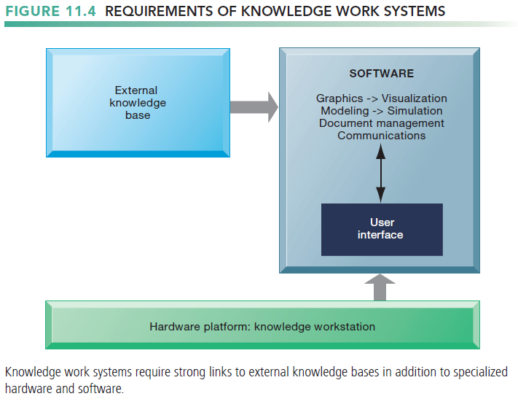

* + Examples of Knowledge Work Systems
* CAD (computer-aided design)
* Creation of engineering or architectural designs
* 3D printing
* Virtual reality systems
* Simulate real-life environments
* 3D medical modeling for surgeons
* Augmented reality (AR) systems
* VRML(Virtual Reality Modeling Language)

1. What are the business benefits of using intelligent techniques for knowledge management?
   * Preface

* Intelligent techniques
* use to capture individual and collective knowledge and to extend their knowledge base
* To capture tacit knowledge
  + - Expert systems, case-based reasoning, fuzzy logic
* Knowledge discovery
  + - Neural networks and data mining
* Generating solutions to complex problems
  + - Genetic algorithms
* Automating tasks
  + - Intelligent agents
* Artificial intelligence (AI) technology
* Computer-based systems that emulate human behavior
  + Capturing Knowledge: Expert Systems
* Preface
* an intelligent technique for capturing tacit knowledge in a very specific and limited domain of human expertise.
* capture the knowledge of skilled employees in the form of a set of rules in a software system.
* The set of rules in the expert system adds to the memory, or stored learning, of the firm.
* lack the breadth of knowledge and the understanding of fundamental principles of a human expert
* Typically perform limited tasks that may take a few minutes or hours, for example
  + - Diagnosing malfunctioning machine
    - Determining whether to grant credit for loan
* by capturing human expertise in limited areas, expert systems can provide benefits, helping organizations make high-quality decisions with fewer people
* Used for discrete, highly structured decision making
* How Expert Systems Work
* Human knowledge must be modeled or represented in a way that a computer can process.
* Expert systems model human knowledge as a set of rules that collectively are called the knowledge base.
  + - The rules are obtained by carefully interviewing one or several “experts” who have a thorough command of the knowledge base for the system or by documenting business rules found in manuals, books, or reports
* Inference engine: Strategy used to search knowledge base
  + - Forward chaining: Inference engine begins with information entered by user and searches knowledge base to arrive at conclusion
    - Backward chaining: Begins with hypothesis and asks user questions until hypothesis is confirmed or disproved

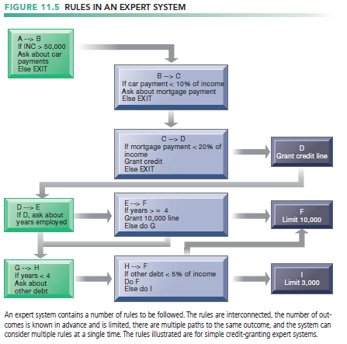

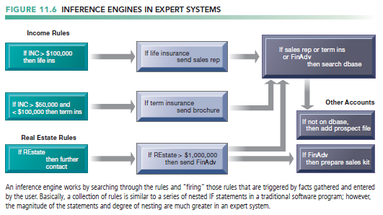

* Examples of Successful Expert Systems
* Successful expert systems
  + - Con-Way Transportation built expert system to automate and optimize planning of overnight shipment routes for nationwide freight-trucking business
* Most expert systems deal with problems of classification
  + - Have relatively few alternative outcomes
    - Possible outcomes are known in advance
* Many expert systems require large, lengthy, and expensive development and maintenance efforts.
  + - Hiring or training more experts may be less expensive
  + Organizational Intelligence: Case-Based Reasoning
* Descriptions of past experiences of human specialists (cases), stored in knowledge base
* System searches for cases with characteristics similar to new one and applies solutions of old case to new case
* Successful and unsuccessful applications are grouped with case
* Stores organizational intelligence: Knowledge base is continuously expanded and refined by users
* CBR found in
  + - Medical diagnostic systems
    - Customer support

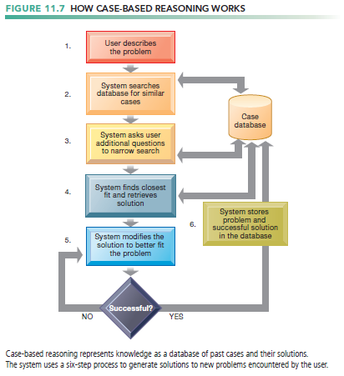

* + Fuzzy Logic Systems
* a Rule-based technology that represents imprecision used in linguistic categories (e.g., “cold,” “cool”) that represent range of values
* Describe a particular phenomenon or process linguistically and then represent that description in a small number of flexible rules
* Organizations can use fuzzy logic to create software systems that capture tacit knowledge where there is linguistic ambiguity.
* Provides solutions to problems requiring expertise that is difficult to represent with IF-THEN rules
* Autofocus in cameras
* Detecting possible medical fraud
* Sendai’s subway system acceleration controls

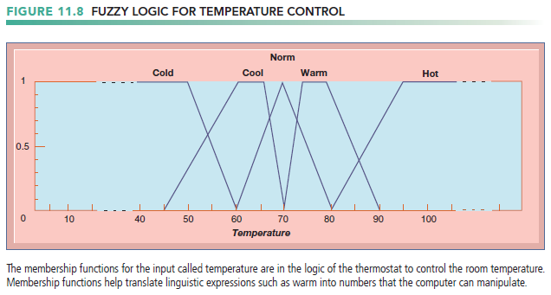

* + Machine Learning
* Preface
* How computer programs improve performance without explicit programming
  + - Recognizing patterns
    - Experience
    - Prior learnings (database)
* Contemporary examples
  + - Google searches
    - Recommender systems on Amazon, Netflix
* Neural Networks
* Find patterns and relationships in massive amounts of data too complicated for humans to analyze
* “Learn” patterns by searching for relationships, building models, and correcting over and over again
* Humans “train” network by feeding it data inputs for which outputs are known, to help neural network learn solution by example
* Used in medicine, science, and business for problems in pattern classification, prediction, financial analysis, and control and optimization

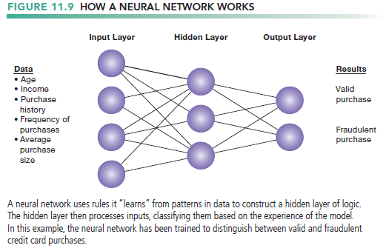

* Genetic Algorithms
* Useful for finding optimal solution for specific problem by examining very large number of possible solutions for that problem
* Conceptually based on process of evolution
  + - Search among solution variables by changing and reorganizing component parts using processes such as inheritance, mutation, and selection
* Used in optimization problems (minimization of costs, efficient scheduling, optimal jet engine design) in which hundreds or thousands of variables exist
* Able to evaluate many solution alternatives quickly

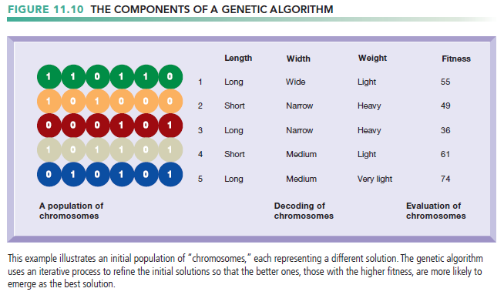

* + Intelligent Agents
* Work without direct human intervention to carry out specific, repetitive, and predictable tasks for user, process, or application
* Deleting junk e-mail
* Finding cheapest airfare
* Chatbots (chatterbots)
* software agents designed to simulate a conversation with one or more human users via textual or auditory methods
* try to understand what you type or say and respond by answering questions or executing tasks.
* Chatbots are typically used in systems for customer service or information acquisition.
* Use limited built-in or learned knowledge base
* Some are capable of self-adjustment, for example: Siri
* Agent-based modeling applications
* Systems of autonomous agents
* Model behavior of consumers, stock markets, and supply chains; used to predict spread of epidemics

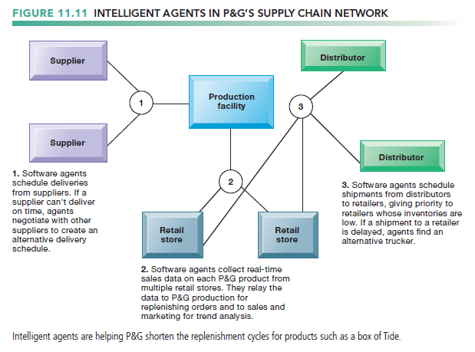

* + Hybrid AI Systems
* Genetic algorithms, fuzzy logic, neural networks, and expert systems integrated into single application to take advantage of best features of each
* For example: Matsushita “neurofuzzy” washing machine that combines fuzzy logic with neural networks